Lakeland’s Little Learners

**Older Two Year Old Room**

**SUPPLIES**

*Please label all supplies.*

**Backpacks** – please provide a reusable bag to place your child’s belongings in. Please do not send any plastic bags or bags with long handles as these are choking hazards. Please do not leave medicines, ointments, or hazardous objects in your child’s bag.

**Diapers & Wipes** – these may be stored in the infant room. Wipes must be stored in a hard plastic container.

**Lotion/Powder/Ointment** – These may be stored in the infant room in a locked box. In order to do so, you must complete a pink medication administration form.

**Bedding** – Please provide a crib sized sheet and blanket for napping.

**Extra Clothes** – Please provide an extra set to be kept in your child’s cubbie. Please replace as seasons and sizes change. Children go outside daily so please provide the appropriate outdoor clothing as well. We ask that you provide close toed shoes for outdoor play.

**Food** – All food & drink must be labeled with your child’s first and last name and the date. We recommend using permanent marker.

***If you forget to bring diapers, wipes, or bedding the center will provide them for your child at a cost of:

Up & Up Diapers $1 each

Up & Up Sensitive Wipes $1 per day

Bedding $1 per day

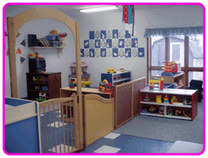

***Two’s Room***

**Welcome to the Older Two’s Room!**

**Lead Teacher: Ms. Colleen Kielas**

When dropping off your child in the morning please wash your child’s hands.

When picking up your child please take home all food and drink containers to be washed & pick up your child’s Daily Sheet from the wall.

At the end of the week please take home your child’s bedding to be laundered.

We provide snacks and milk at no charge. Children over 2 years are served 1% milk.

If you would like your child to eat our hot lunch please notify the office.

Sunscreen – If your child arrives before 9:30 am please apply sunscreen at home to allow the sunscreen to be effective upon arrival.